“INSTALLATION OF PHOTOVOLTAIC SYSTEMS AT O.A.K. SA’s WATER TANKS AND AUTONOMOUS OPERATION OF WATER PUMPS AT THE PUMP STATIONS”,

The Organization for the Development of Crete S.A. (O.A.K. S.A.) has completed the installation of a stand-alone solar water pump system at the Tzivara water pump station in the region of Apokoronas, Crete. The photovoltaic panels were installed on the roof of the water tank and the energy produced is used to operate three stand-alone, non–PPC connected water pumps.

The specific project “INSTALLATION OF PHOTOVOLTAIC SYSTEMS AT O.A.K. SA’s WATER TANKS AND AUTONOMOUS OPERATION OF WATER PUMPS AT THE PUMP STATIONS”, with a total budget of 558.906,05 €, was co-financed from the European Economic Area (EEA) and the Public Investment Program.

The initial targets regarding the integration of Renewable Energy Resources at the water tank are estimated to be:
- Total RES production of 189,55 MWh/year,
- CO₂ emissions reduction of 144,10 tons/year

Indicative photos of the Project are given below:

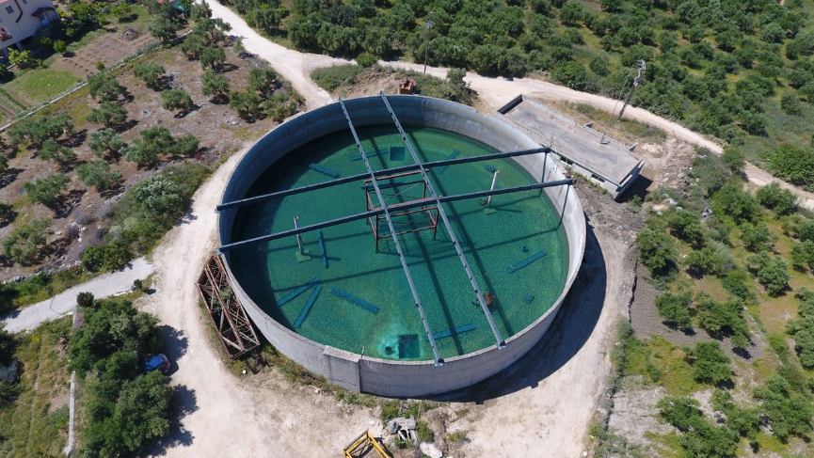
The water tank has a diameter of 40 meters, a height of 6.5 meters and water capacity of 6.450 m³
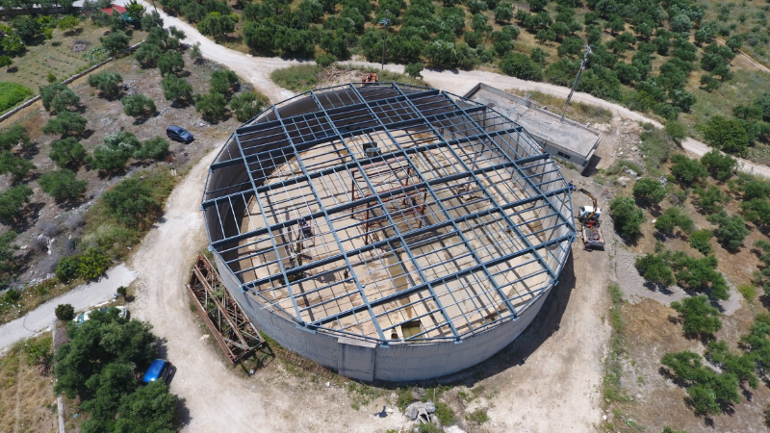

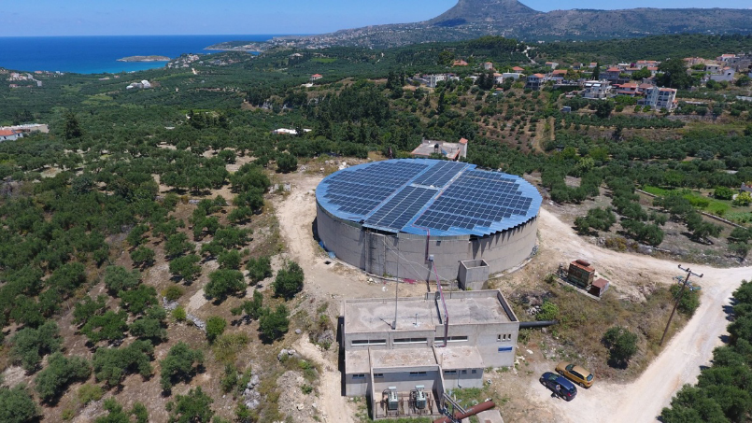

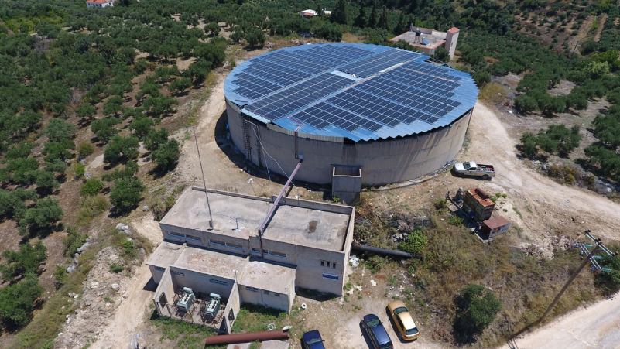

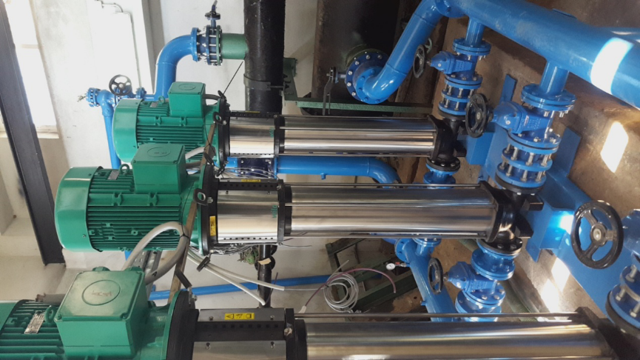
The 3 vertical water pumps

